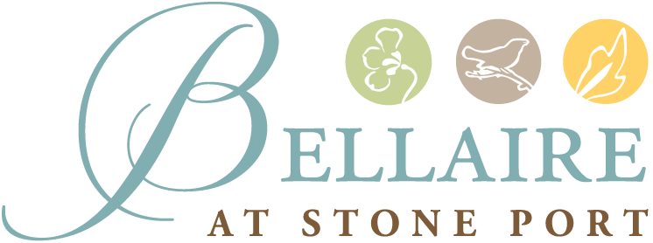

November 3, 2021

Greetings,

This letter is to inform our families, residents, and team members that we have been notified of a COVID positive team member. The team member is vaccinated and has not been in the community since 11/1. Our team member will be unable to return to work for a minimum of 10 days after the date of their positive test.

We have reported this case to the Department of Social Services and to the Virginia Department of Health. The Virginia Department of Health has recommended that we continue to monitor all residents for signs or symptoms daily.

We have not made any changes to our visitation or activities at this time. Residents are encouraged to continue wearing masks when outside of their apartments. Thank you for your patience and understanding. We will continue to communicate any updates or changes to each of our residents, their families and team members.

Sincerely,

Jessica Gale, LNHA
Executive Director

